Integration between Canvas App to Sql through Sharepoint

Start Time :This is for the Showing data into 12 hr with am pm

//ThisItem.StartTime

If(Hour(ThisItem.StartTime)=0,"12",If(Hour(ThisItem.StartTime)>12,Text(Hour(ThisItem.StartTime)-12,"00"),Text(Hour(ThisItem.StartTime),"00")))&":"&If(Minute(ThisItem.StartTime)<10,"0"&Text(Minute(ThisItem.StartTime)),Text(Minute(ThisItem.StartTime)))&":"&If(Second(ThisItem.StartTime)<10,"0"&Text(Second(ThisItem.StartTime)),Text(Second(ThisItem.StartTime)))&" "&If(Hour(ThisItem.StartTime)>=12,"PM","AM")

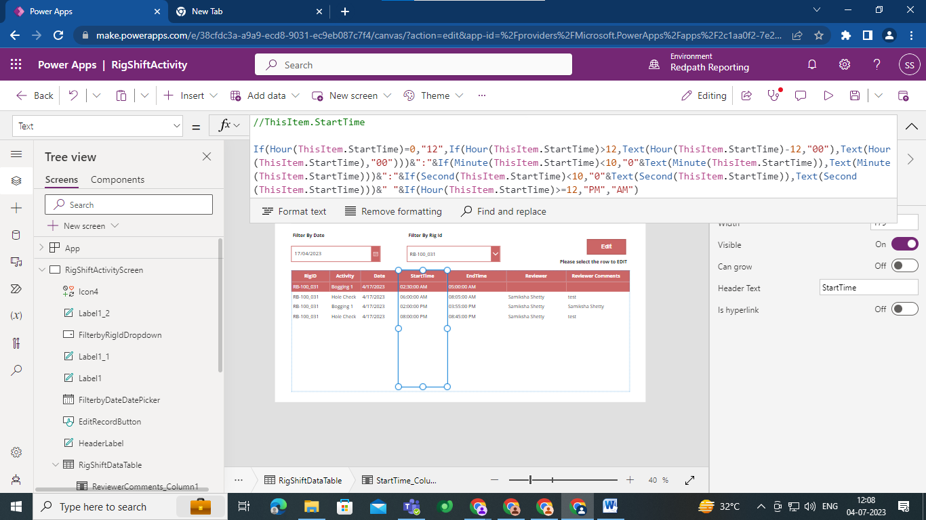

End Time :This is for the Showing data into 12 hr with am pm

//ThisItem.EndTime

If(Hour(ThisItem.EndTime)=0,"12",If(Hour(ThisItem.EndTime)>12,Text(Hour(ThisItem.EndTime)-12,"00"),Text(Hour(ThisItem.EndTime),"00")))&":"&If(Minute(ThisItem.EndTime)<10,"0"&Text(Minute(ThisItem.EndTime)),Text(Minute(ThisItem.EndTime)))&":"&If(Second(ThisItem.EndTime)<10,"0"&Text(Second(ThisItem.EndTime)),Text(Second(ThisItem.EndTime)))&" "&If(Hour(ThisItem.EndTime)>=12,"PM","AM")

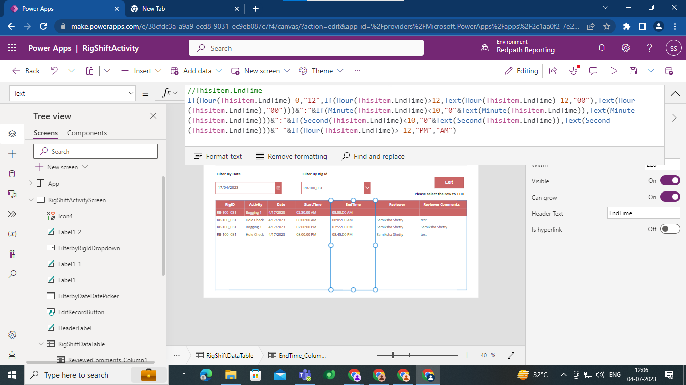

//Set selected start time in to variable

Set(SelectedStartTime,If(Hour(RigShiftDataTable.Selected.StartTime)=0,"12",If(Hour(RigShiftDataTable.Selected.StartTime)>12,Text(Hour(RigShiftDataTable.Selected.StartTime)-12,"00"),Text(Hour(RigShiftDataTable.Selected.StartTime),"00")))&":"&If(Minute(RigShiftDataTable.Selected.StartTime)<10,"0"&Text(Minute(RigShiftDataTable.Selected.StartTime)),Text(Minute(RigShiftDataTable.Selected.StartTime)))&":"&If(Second(RigShiftDataTable.Selected.StartTime)<10,"0"&Text(Second(RigShiftDataTable.Selected.StartTime)),Text(Second(RigShiftDataTable.Selected.StartTime)))&" "&If(Hour(RigShiftDataTable.Selected.StartTime)>=12,"PM","AM"));

//Set selected End time in to variable

Set(SelectedEndTime,If(Hour(RigShiftDataTable.Selected.EndTime)=0,"12",If(Hour(RigShiftDataTable.Selected.EndTime)>12,Text(Hour(RigShiftDataTable.Selected.EndTime)-12,"00"),Text(Hour(RigShiftDataTable.Selected.EndTime),"00")))&":"&If(Minute(RigShiftDataTable.Selected.EndTime)<10,"0"&Text(Minute(RigShiftDataTable.Selected.EndTime)),Text(Minute(RigShiftDataTable.Selected.EndTime)))&":"&If(Second(RigShiftDataTable.Selected.EndTime)<10,"0"&Text(Second(RigShiftDataTable.Selected.EndTime)),Text(Second(RigShiftDataTable.Selected.EndTime)))&" "&If(Hour(RigShiftDataTable.Selected.EndTime)>=12,"PM","AM"));

//For Split Start Time

Set(SelectedStartHour,Text(Value(Left(SelectedStartTime,Find(":",SelectedStartTime)-1)),"00"));

Set(SelectedStartMinute,Text(Value(Mid(SelectedStartTime,Find(":",SelectedStartTime)+1,2)),"00"));

Set(SelectedStartSecond,Text(Value(Mid(SelectedStartTime,Find(":",SelectedStartTime)+4,2)),"00"));

Set(SelectedStartAMPM,Right(SelectedStartTime,2));

//For Split End Time

Set(SelectedEndHour,Text(Value(Left(SelectedEndTime,Find(":",SelectedEndTime)-1)),"00"));

Set(SelectedEndMinute,Text(Value(Mid(SelectedEndTime,Find(":",SelectedEndTime)+1,2)),"00"));

Set(SelectedEndSecond,Text(Value(Mid(SelectedEndTime,Find(":",SelectedEndTime)+4,2)),"00"));

Set(SelectedEndAMPM,Right(SelectedEndTime,2));

Navigate(EditRigRecordScreen,ScreenTransition.Fade)



//Set the date into dropdown

Set(

startDropdownSelectedTime,

Concatenate(

Text(starthh.Selected.Value, "[$-en-US]00"),

":",

Text(startmm.Selected.Value, "[$-en-US]00"),

":",

Text(startss.Selected.Value, "[$-en-US]00"),

" ",

Text(startampm.Selected.Value)

)

);

Set(

endtDropdownSelectedTime,

Concatenate(

Text(endhh.Selected.Value, "[$-en-US]00"),

":",

Text(endmm.Selected.Value, "[$-en-US]00"),

":",

Text(endss.Selected.Value, "[$-en-US]00"),

" ",

Text(endampm.Selected.Value)

)

);

//Collect the data into one object and send that into power automate

Collect(FormData,{

RigID:DataCardValue1.Text,

Id:DataCardValue9.Text,

StartTime:startDropdownSelectedTime,

EndTime:endtDropdownSelectedTime,

Comment:CommentTextInput.Text,

Reviewer:DataCardValue6.Text

});

Set(FormObj, JSON(FormData));

//Call power automate

'PA:UpdateRigCanvasapptoSql'.Run(FormObj);

SubmitForm(RigShiftForm);

Refresh(rig_shift_review01);

Navigate(RigShiftActivityScreen,ScreenTransition.Fade)

//Filter the Data table based on date and rig Id

Filter(rig_shift_review01,Date=FilterbyDateDatePicker.SelectedDate && RigID=FilterbyRigIdDropdown.Selected.Value)

